Computer Networks

Lab Task #12

Saad Ahmad

20P-0051

Add 1x PC, 2x Laptops, 2x switch, 2x routers and 2x servers and connect them all.

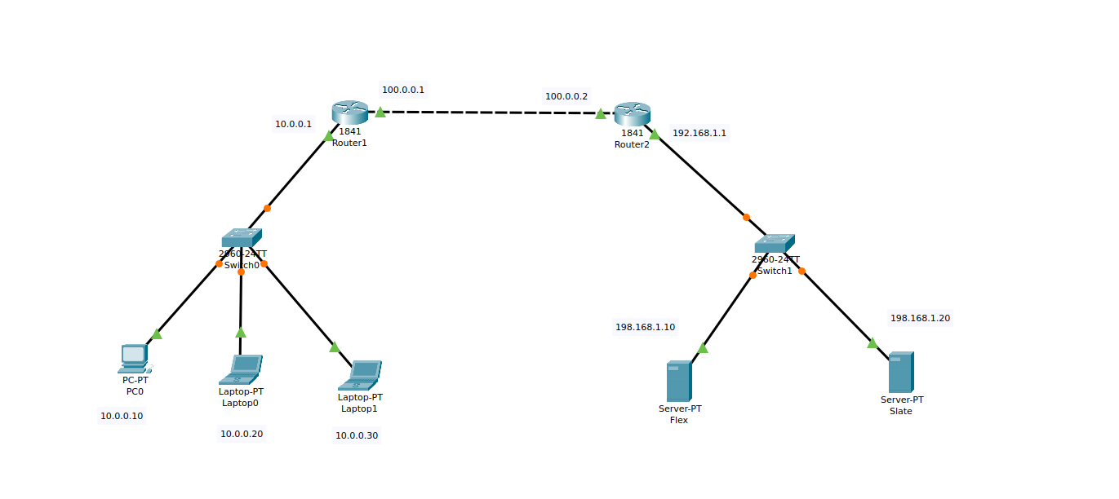

Now assign the IP addresses to the PC, laptops, servers and the routers:

**PC:** 10.0.0.10

**Laptop0:** 10.0.0.20

**Laptop1:** 10.0.0.30

**Server1:** 192.168.1.10

**Server2:** 192.168.1.10

**F0/1 of R1:** 100.0.0.1

**F 0/1of R2:** 100.0.0.2

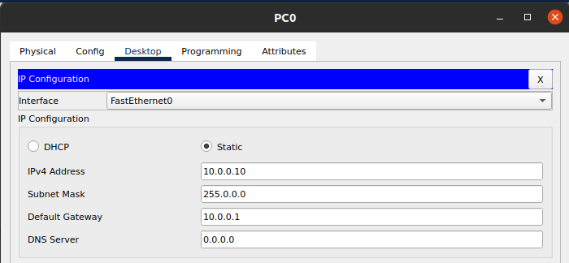

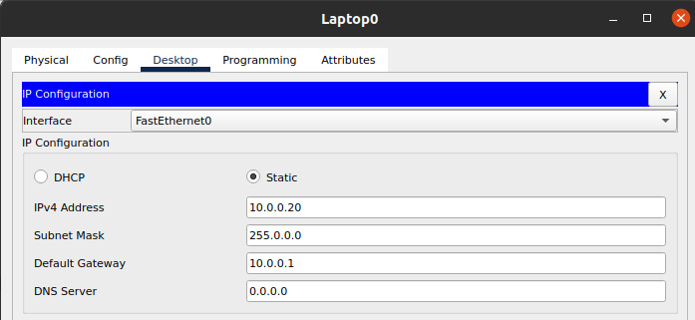

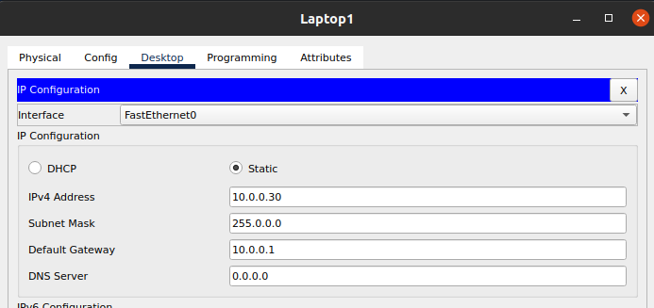

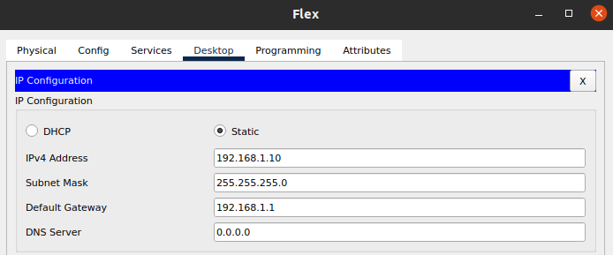

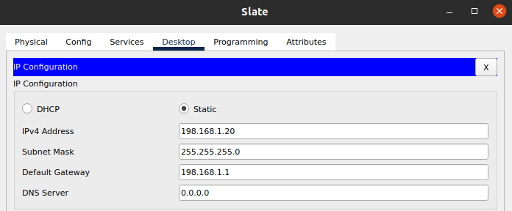

Configuring Router 1:

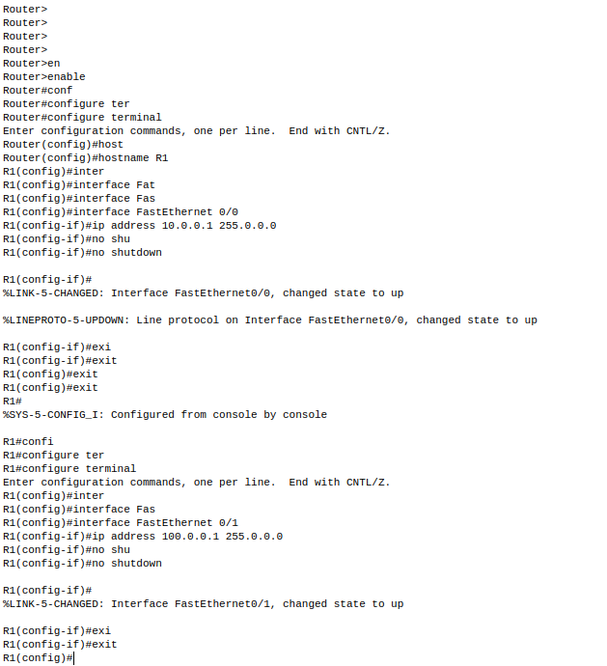

Configuring Router 2:

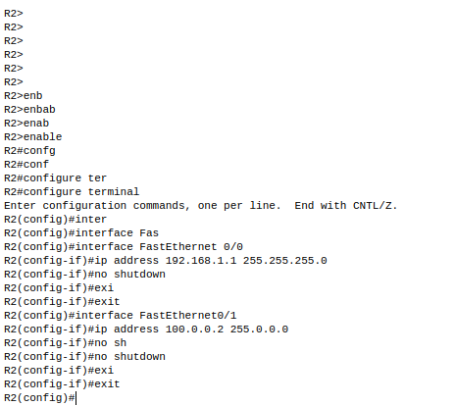

Configure Static NAT:

Router 1:

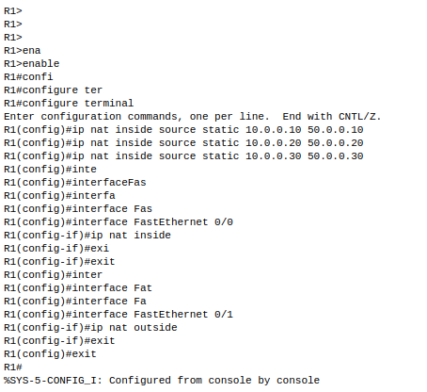

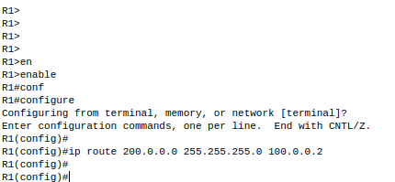

Router 2:

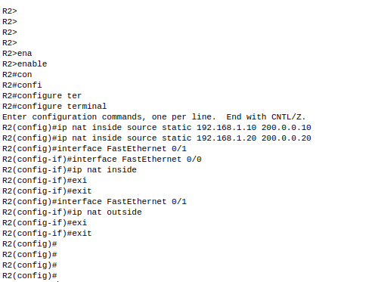

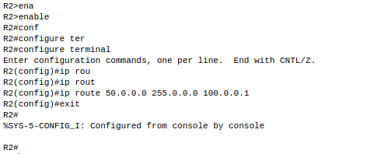

Checking the connection:

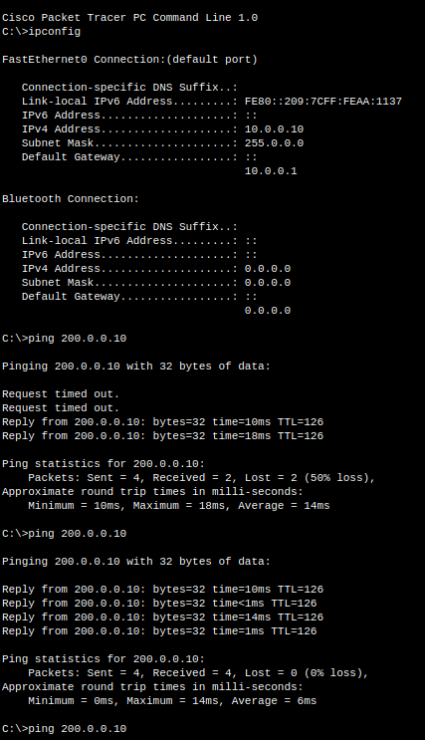

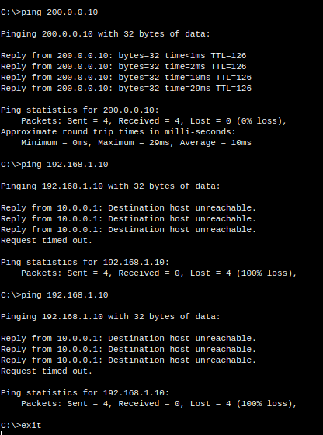

**Note:**

I have tried again and again to ping the slate server but I am receiving the same message of request time out and this issue was already discussed with you in the lab.